Proton

LED Explosion-proof Light Fixture of
«SPV-220-001» type

OPERATING MANUAL
KENS. 676253.107 OM

JSC «Proton»
Orel
The present operating manual (further named OM) is used for operating LED Explosion-proof light fixture of “SPV-220-001” type (further named the light).
The OM contains construction data, operating rules and working conditions, maintenance recommendations and other data necessary for the right operating of the light.
Only after being instructed, going through safety working methods, checking of safety rules with further certifying a qualification for safety arrangements, one is admitted for electrical installation, inspection and maintenance of the light unit.

1 Description and Operating
1.1 Light Assignment
1.1.1 The light is used for operating in the AC supply for outdoor and indoor illumination of industrial objects.
The application area – explosive zones 1,2 according to IEC 60079-10-1, dangerous zones 21,22 for combustible dust according to IEC 60079-10-2, explosion-proof marking according to IEC 60079-14.
1.1.2 The light is designed to work from external power supply.
1.1.3 The Structure of the Conditional Assignment

СПВ-220-ХХХ-ХХ
three-number figure designates a declared supply 220V.

three-number figure designates a batch number.

two-number figure designates the design variant.

1.2. Technical data
1.2.1. Nominal supply voltage - 220 V, current type AC (50±10%) Hz. Supply voltage range - 176÷264 V, current type AC (50±10%) Hz or 250÷370 V, current type DC.
1.2.2. Light source – LED semiconductor device.
1.2.3. The light power consumption, nominal **:
SPV-220-001-01 - 40 W;
SPV-220-001-02 - 60 W.
** Consumption power value can differ by 10%.
1.2.4. Light distribution curve – cosine.
1.2.5. Light intensity, not less than:
SPV-220-001-01 - 4400 Lm;
SPV-220-001-02 – 6600 Lm.
1.2.6. Ex marking for explosive gas/dust atmospheres:
- TR CU: 1 Ex d e IIВ+H₂ T5 Gb/ Ex tb IIIC Т95°С Db;
- IECEx: 1 Ex d e op is IIВ+H₂ T5 Gb/ Ex tb IIIC Т95°С Db;
- АТЕХ: II 1 G Ex d e IIB+H₂ T5 Gb/ III 1 D Ex tb IIIC T95°C Db.
1.2.7. The light weight, not more than – 11 kg;
1.2.8. Ambient operating temperature from minus 40°С up to plus 50°С.
1.2.9. Climatic performance MCC, placement category 1 up to IEC 60721-2-1:2013:1982, IEC 60068-1:2013.
1.2.10. IP up to IEC 529 is not worse than IP65.
1.2.11. Durability when conforming to operating conditions is not less than 100 000 hours.
1.2.12. The light physical configuration corresponds to the physical configuration samples description KENS.676253.107 D2.
1.2.13. The outward design and construction of the light are shown on Pic.1, Pic.2, Pic.3, Pic.4, Pic.5, Pic.6, Pic.7, Pic.8.

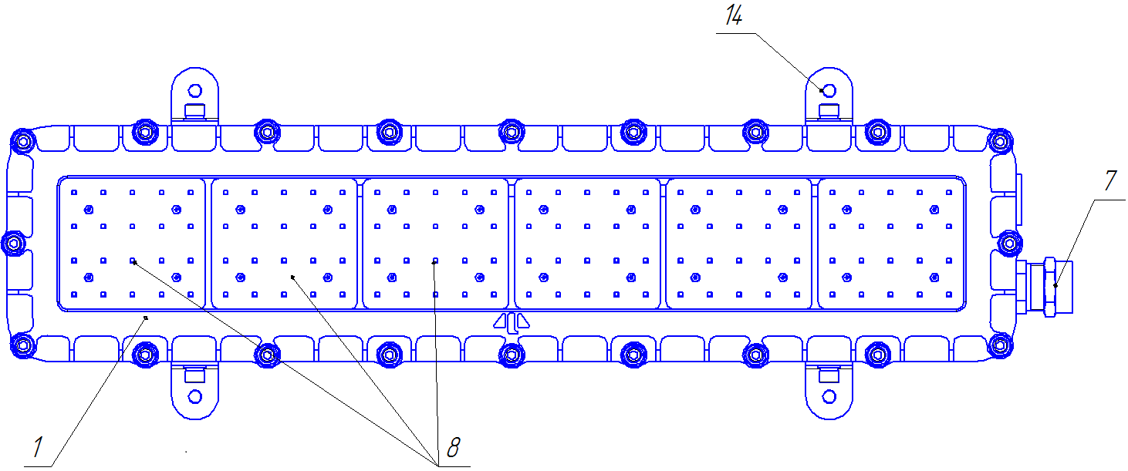
Pic. 1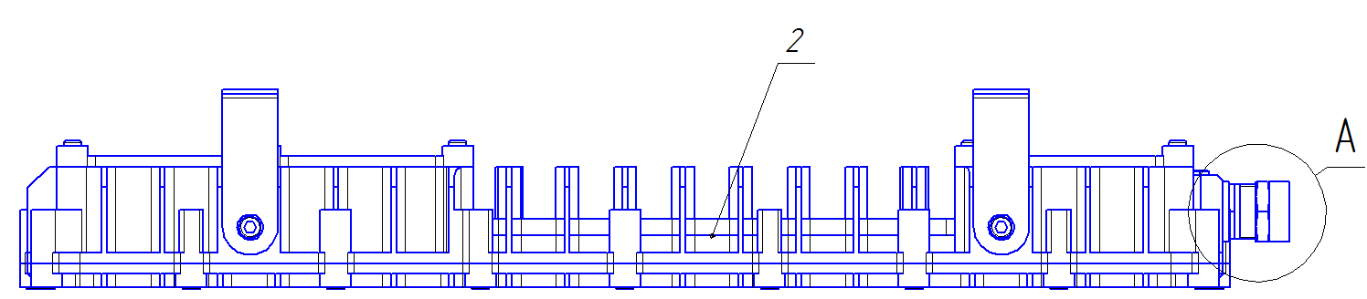
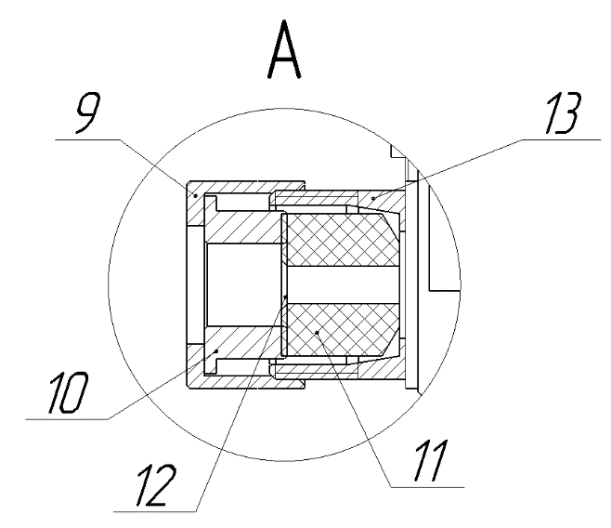
Pic. 2
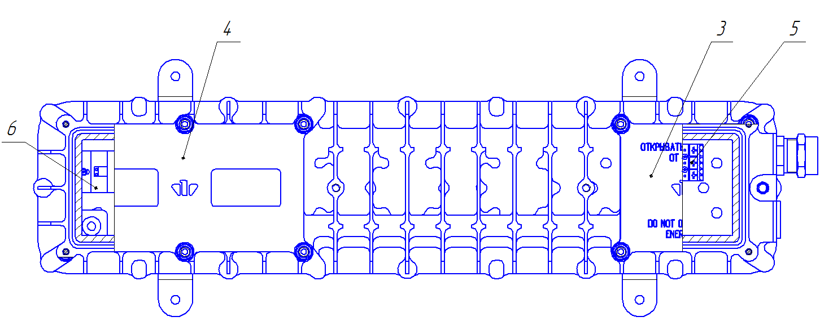
Pic.3
1 – lid with glass; 2 - housing; 3 - lid; 4 – lid; 5 – terminal block; 6 –driver; 7 – cable entry; 8 – LED module; 9 – nut; 10 –joint; 11 – sealing bushing; 12 – washer; 13 - connection; 14 – angle.

1.3 SET (the light completeness):
1.3.1 The set consists of:
- LED Explosion-proof light fixture of “SPV-220-001” type – 1 pce.;
- a passport, an operating manual, a certificate copy and a certificate annex copy;
- an angle – 1 pce.

1.4 Construction and Operation
1.4.1 LED Explosion-proof light fixture of “SPV-220-001” type (see Pic. 1) consists of the housing (pos.2) with installed LED modules (pos.8), the driver (pos.6), the terminal block (pos.5) and the cable entry (pos.7) inside it. On the housing the lid with glass (pos.1), the lid (pos.3), the lid (pos.4) and the angles (pos.14) are fixed. The cable entry (pos.7) consists of the nut (pos.9), the joint (pos.10), the sealing bushing (pos.11), the washer (pos.12) and the connection (pos.13) (see Pic.9).
1.4.2 The designation of constitutive parts of the light (see Pic.1):
- the angles are used to fit the light on the surfaces;
- the angles are fixed to the light with 4 M8 screws;
- the connection of the network cable is done to the contact device;
- the glass and the lid connection way guarantees the necessary hermeticity and the light protection;
- the sealing elements provides the light protection level from external factors influence not worse than IP65.

1.5 Measuring tools, instruments, accessories
1.5.1 To open the explosion-proof housing, to connect the light to the network, to install and maintain preventively the usual electro-installation instruments and measuring tools are used.

1.6 Marking
The marking is put on the light outer surface on the clearly visible place via the way that guarantees the stability to the environment influence and contains:
- the trademark of the manufacturer;
- the name of the company;
- the address of the company-manufacturer;
- the light type;
- the technical conditions logical number;
- controlled supply voltage;
- maximum power consumption;
- ambient temperature range;
- IP code;
- manufacturing year and month;
- the light serial number;
- the certification body name or sign and the certificate No.;
- special Ex-marking for explosive gas or dust atmosphere.
Ex-marking for explosive gas atmospheres.

1 Ex d e IIВ+$Н_{2}$ T5 Gb
Protection level: 1 – explosion-proof equipment;
the sign, showing that the equipment corresponds to Ex standards;
Ex type: d – explosion-proof housing; e – increased safety;
the group of electrical equipment, intended for the usage in explosive gas atmospheres (excluding mines, dangerous on mine gases);
the temperature class or the max equipment surface temperature: Т5≤100ºС;
the equipment explosion protection level: Gb – explosion protection level given to the equipment for explosive gas atmospheres with “high” explosion protection level, that is not the source of inflammation in normal exploitation conditions or at taken into account faults that occur irregularly.

Ex-marking for explosive dust atmospheres.
Ex tb IIIC Та95°C Db
the sign, showing that the equipment corresponds to Ex standards;
Ex type regarding the electrical equipment for using in explosive dust atmospheres, tb – protection by the housing;
the group of electrical equipment, intended for the usage in the places (except mine underground workings and their surface buildings), dangerous because of explosive dust atmospheres containing conductive dust;
the value of maximum allowed temperature of the equipment surface;
the equipment explosion protection level given to the equipment for explosive dust atmospheres with “high” explosion protection level, that is not the source of inflammation in normal exploitation conditions or at supposed faults that unlikely might be the source of inflammation during the period of time starting with the moment of explosive dust atmosphere appearance till the moment of electric supply switching off.

1.7 Packaging
1.7.1 The package of the light is made according to GOST 23216 for storage conditions 2 (c) IEC 60721-2-1:2013:1982, IEC 60068-1:2013.
1.7.2 The lights should be packed into a cargo container that provides their safety and protection against mechanical damages.
1.7.3 Manipulation signs should be marked on the cargo container: “Fragile”, “Keep dry”, “Top”, “Max quantity when stocking” according to ISO 780:2015.

2 Intended Usage

2.1 The connection to the power line (Pic.11) should be done in the following order:
- to take off the lid (pic.3 pos.3),
- to put the power wire through the cable entry (pic.3 pos.7) and connect the wire to the terminal block (pic.3 pos.5) L,N, 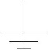 ,
- to set the lid (pos.3) tightening 4 screws M6 with loading from 9,3 to 9,6 Nm,
- to tighten the nut of the cable entry (pic.2 pos.9) with loading from 20 to 30 Nm,
- to check if the light is functioning by applying the voltage.

2.2 The lights exploitation and the work safety actions should be done according to the requirements of “Electrical engineering regulations”.

2.3 It is necessary to observe the following:
- the installation, assembly and disassembly should be done by the personal having studied the present document and having been instructed on the safety actions while working on the electricity-generating equipment;
- to check visually the light if there are any damages of the housing details and the integrity of the sealing elements.

2.4 It is forbidden:
- to use the light in zones which do not correspond to Ex-marking;
- to unlid the light if it is connected to the power line;
- to use the light without connection to the ground;
- to unscrew pos.4, open the housing with the driver and LED modules.

2.5 The connection of the light housing to the ground should be done via a separate cable cord.

2.6 The explosion-proofness of the light is guaranteed by the encasement of the light source, the driver and the contact device inside the explosion-proof housing that prevents the penetration of explosive atmosphere inside the housing.

2.7 The lights are provided with the means that guarantee the explosion-proofness during the exploitation:
- there is the warning label: «DO NOT OPEN WHILE ENERGIZED» (Pic.10);
- there is inner ground element, there are the ground signs nearby, the light is grounded using a separate cable cord;
- the protective glass is heat-strengthened and heat-resistant;
- the cable is thickened by the cable entry;
- IP up to IEC 529 is not worse than IP65.

2.8 The light installation and the energy supply should be done in strict correspondence to the installation norms and rules for explosive atmospheres acting on the territory of the application country and the present manual.

2.9 Before the installation the light should have the exterior check, a special attention should be paid to the integrity of the housing, the glass.

2.10 The place of the cable cords connection should be thoroughly cleaned to achieve the firm contact.

2.11 In the light exploitation process the maintenance personnel should pay a special attention to the condition of explosion-proofness means, to control the concentration of explosive mixture in production zones.

2.12 Not less than once a year there should be done the light technical maintenance. To do it there should be done the following actions:
- to switch the power off;
- to clean the light and to do the exterior check;
- to take the lid off (pos.3) and to check the contact connections including the ground elements;
- to check the integrity of the sealing cord, to replace the sealing cord (Cord 2-5C Ø3,2 GOST 6467-79 or analogous) if necessary;
- to assemble the light in the diverse order.

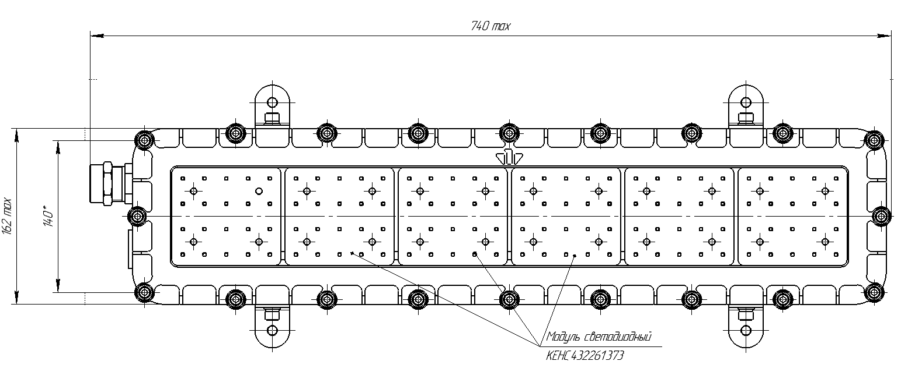
Pic. 4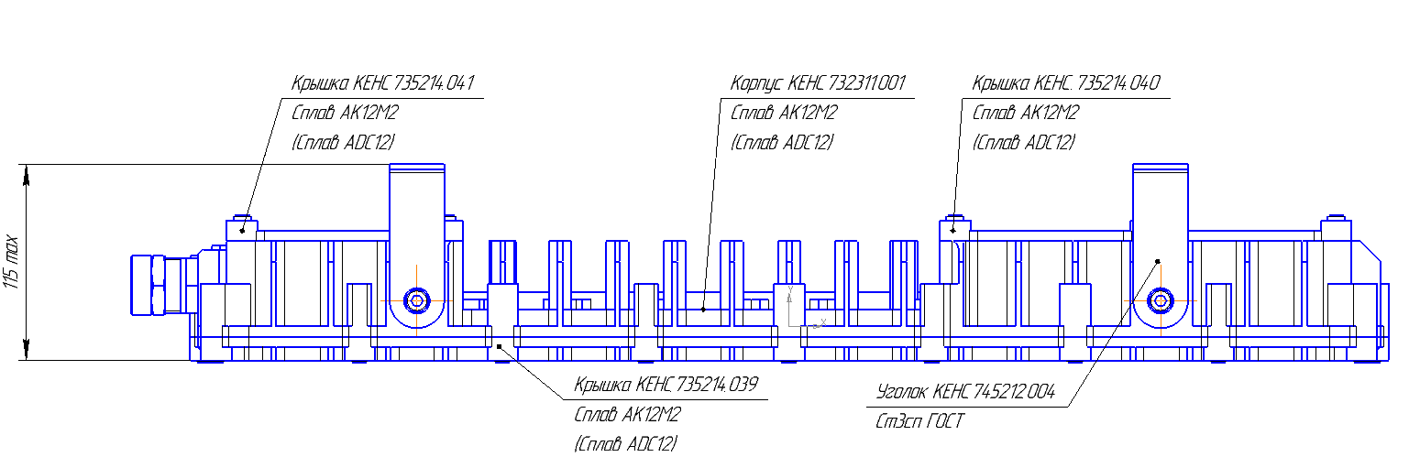

Pic. 5

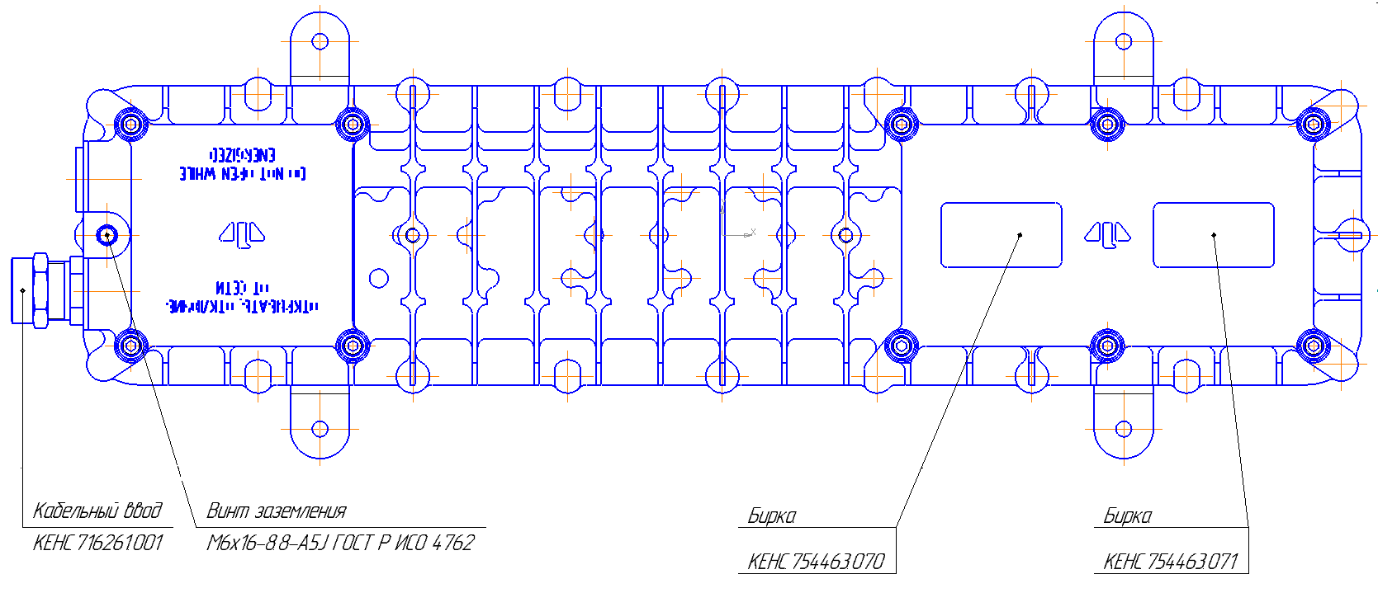
Pic. 6
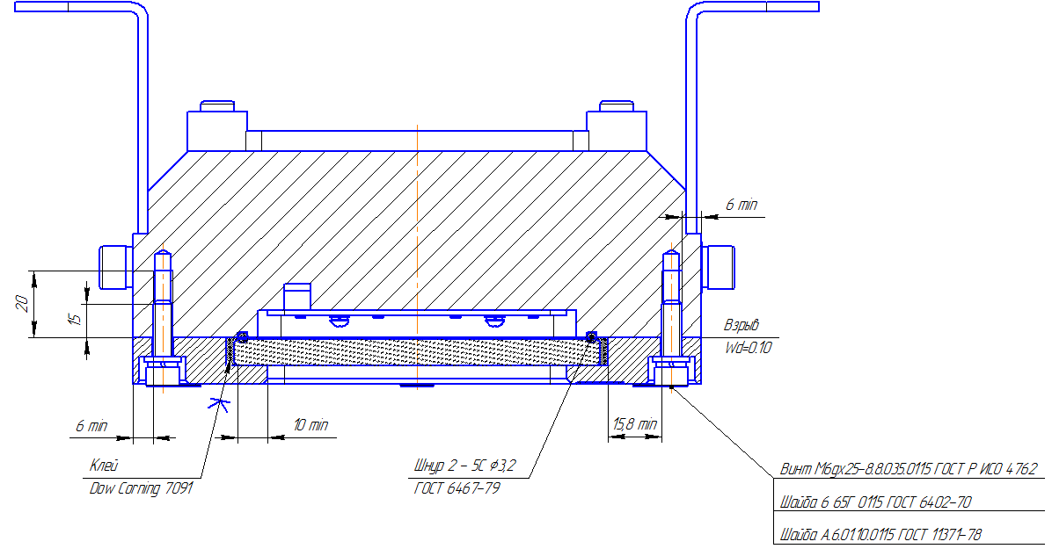
Pic. 7

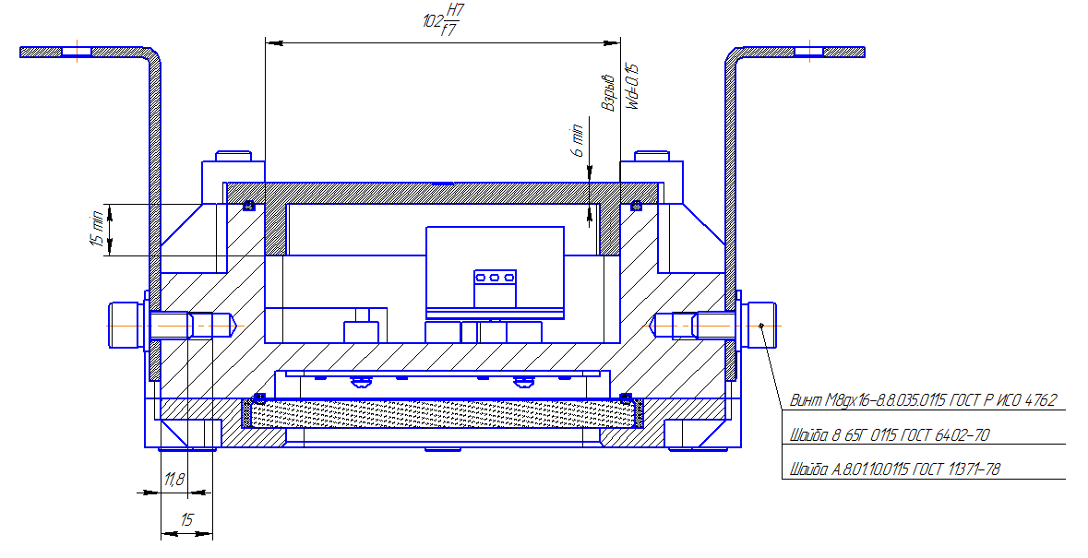
Pic.8

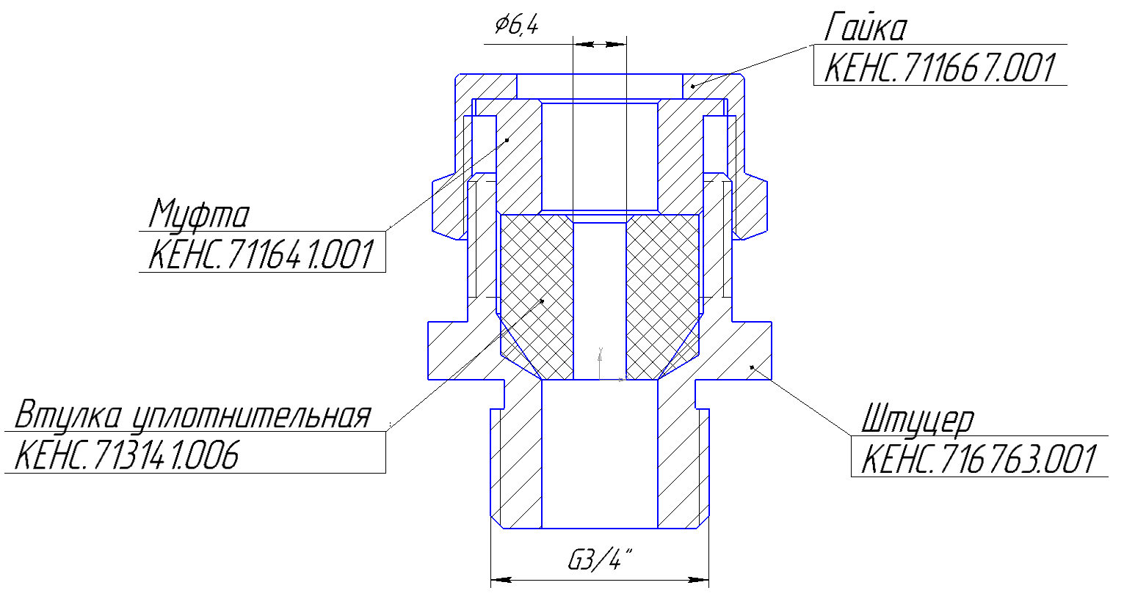 | 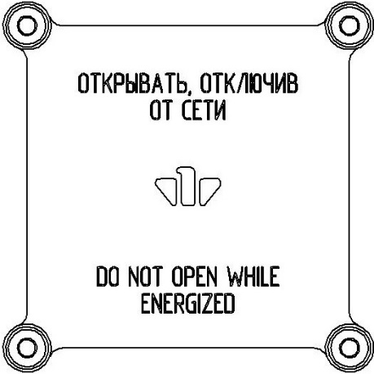
Pic. 9 | Pic. 10

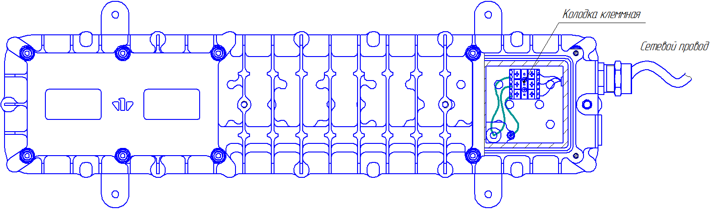

Pic. 11 – The scheme of the power connection

3 Storage and transportation

3.1 The light should be kept packed according to GOST 23216 for the storage conditions.
3.2. Transportation of the light can be carried out by any transport at any distance.
3.3. When keeping and transporting the light should be protected against any atmospheric fallout.

4 Recycling

4.1 All materials used in LED Explosion-proof light fixture of “SPV-220-001” type are not dangerous for people’s life and environment. On completing operation they should be recycled in accordance with the present rules.

5 Manufacturer’s Warranty
5.1 The company-manufacturer guarantees conformance of the light’s requirements to technical specifications and normal operating within 5 years if the customer meets requirements of transportation rules, storage, installation and operating rules.
5.2. Within the warranty period damaged lights should be changed charge free by the manufacture at the conditions of observing installation and operating rules by the customer.
5.3 Service life is not less than 10 years.

6 Reclamation data

6.1. The manufacturer should be laid reclamation claims in case of discovering damages that may lead to the breakdown of LED Explosion-proof light fixture of “SPV-220-001” type before the warranty expiration.
The manufacturer’s address:
19, Leskova str., Orel, 302040, RUSSIA, JSC “Proton”.
6. 2. In reclamation there should be specified:
the light brand, damages, conditions at which they are discovered, the whole operation period.
There should be attached a copy of the payment document for the light.

7 Acceptance Certificate

7.1 LED Explosion-proof light fixture of “SPV-220-001” type is manufactured and approved in accordance with the compulsive State standards requirements, the present technical specifications TS 3461–018–41677105–2016 and approved to be suitable for the operation.

Placeholders QCD stamp

________________________________

Date

