JSC “Proton”

LED Explosion-proof Light Fixture of
«SPV-220-005» type

OPERATING MANUAL
KENS. 676253.112 OM

JSC «Proton»
Orel
The present operating manual (further named OM) is used for operating LED Explosion-proof light fixture of “SPV-220-005” type (further named the light).
The OM contains construction data, operating rules and working conditions, maintenance recommendations and other data necessary for the right operating of the light.
Only after being instructed, going through safety working methods, checking of safety rules with further certifying a qualification for safety arrangements, one is admitted for electrical installation, inspection and maintenance of the light unit.

1 Description and Operating
1.1 Light Assignment
1.1.1 The light is used for operating in the AC supply or DC supply for outdoor and indoor illumination of industrial objects.
The application area – explosive zones 1,2 according to IEC 60079-10-1, dangerous zones 21,22 for combustible dust according to IEC 60079-10-2, explosion-proof marking according to IEC 60079-14.
1.1.2 The light is designed to work from external power supply.
1.1.3 The Structure of the Conditional Assignment

SPV-220-ХХХ-ХХ
three-number figure designates a declared supply 220V.

three-number figure designates a batch number.

two-number figure designates the design variant.

1.2 Technical data
1.2.1 Nominal supply voltage - 220 V, current type AC (50±10%) Hz. Supply voltage range - 176÷264 V, current type AC (50±10%) Hz or 250÷370 V, current type DC.
1.2.2 Light source – LED semiconductor device.
1.2.3 The light power consumption, nominal **:
SPV-220-005-01 - 20 W;
SPV-220-005-02 - 30 W;
SPV-220-005-03 - 40 W;
SPV-220-005-04 - 60 W;
** Consumption power value can differ by 10%.
1.2.4 Light distribution curve – cosine.
1.2.5 Light intensity, not less than:
SPV-220-005-01 - 2800 Lm;
SPV-220-005-02 – 4200 Lm;
SPV-220-005-03 - 5600 Lm;
SPV-220-005-04 - 8400 Lm;
1.2.6 Ex marking for explosive gas/dust atmospheres:
- TR CU: 1 Ex d e IIC T5 Gb/ Ex tb IIIC Т95°С Db;
- IECEx: 1 Ex db e op is IIC T5 Gb/ Ex tb IIIC Т95°С Db;
- АТЕХ: II 1 G Ex db e IIC T5 Gb/ III 1 D Ex tb IIIC T95°C Db.
1.2.7 The light weight, not more than – 4,5 kg;
1.2.8 Ambient operating temperature from minus 40°С up to plus 50°С.
1.2.9 Climatic performance MCC, placement category 1 up to IEC 60721-2-1:2013, IEC 60068-1:2013.
1.2.10 IP up to IEC 529 is not worse than IP65.
1.2.11 Durability when conforming to operating conditions is not less than 100 000 hours.
1.2.12 The light physical configuration corresponds to the physical configuration samples description KENS.676253.112 D2.
1.2.13. The outward design and construction of the light are shown on Pic. 1, Pic. 2 and Pic. 3.
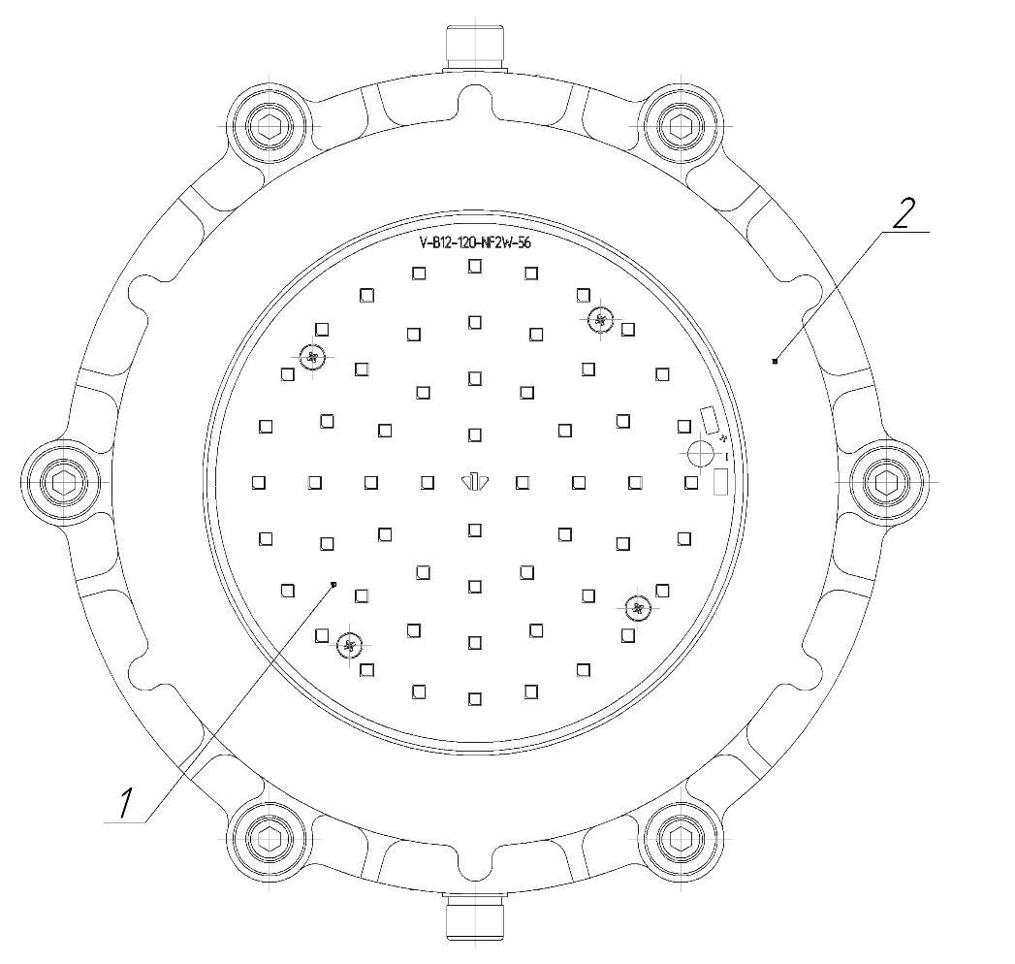
Pic. 1

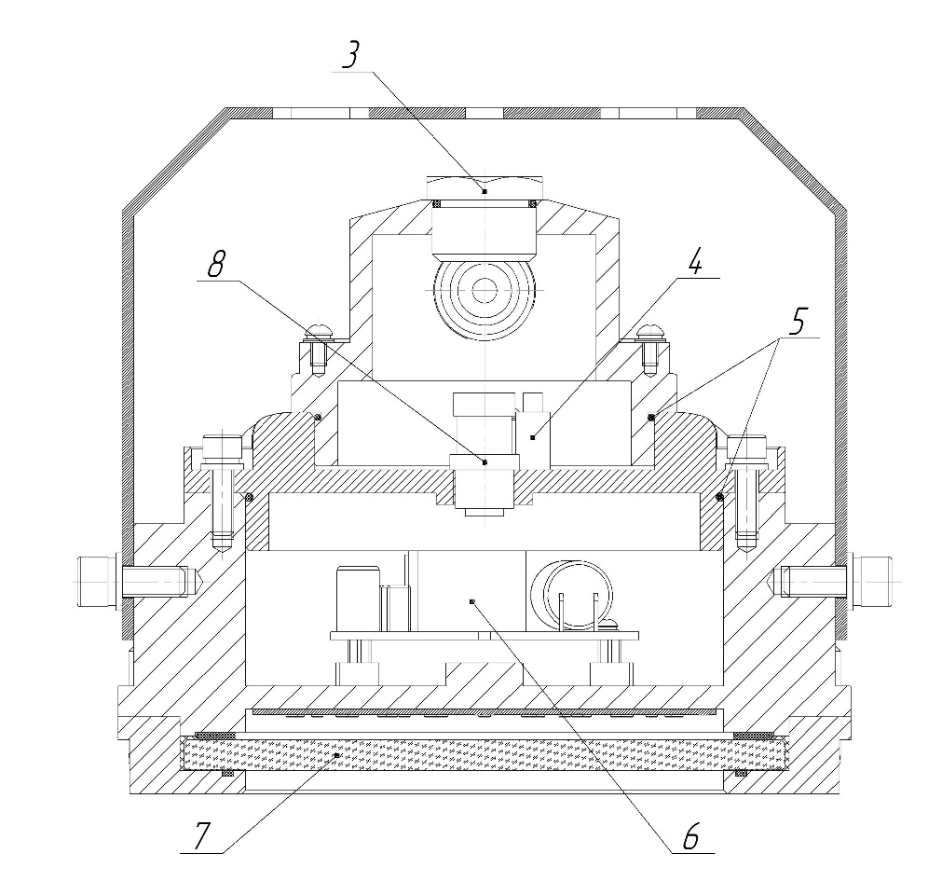
Pic. 2

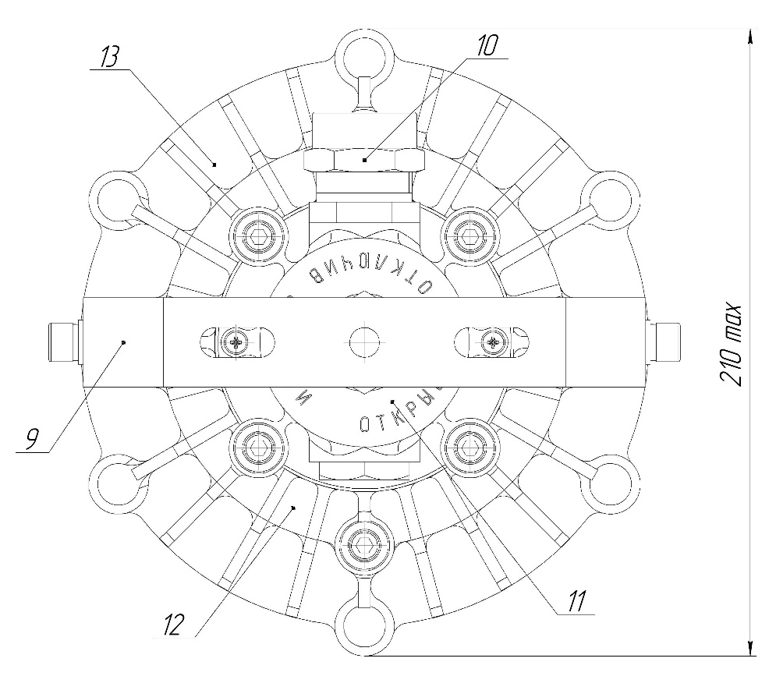
Pic.3

1 – LED module; 2 – ring; 3 – connector; 4 – blind plug; 5 – contact device; 6 – driver; 7 – glass; 8 – gasket ring; 9 – bracket; 10 – lid; 11 – cable gland; 12 – lid; 13 – housing.
1.3 SET (the light completeness):
1.3.1 The set consists of:
- LED Explosion-proof light fixture of “SPV-220-005” type – 1 pce.;
- a passport – 1 pce;
- an operating manual – 1 pce;
- a certificate copy and a certificate annex copy – 1pce;
- a bracket – 1 pce.

1.4 Construction and Operation
1.4.1 LED Explosion-proof light fixture of “SPV-220-005” type (Pic. 1) consists of the housing (pos.13), the ring (pos.2), the lid (pos.10), the lid (pos.12), LED module (pos.1), the glass (pos.7), the driver (pos.6), the cable gland (pos.11), the bracket (pos.9), fitting elements.

1.4.2 The designation of constitutive parts of the light (Pic.1):
- the bracket (pos. 4) is used to fit the light on the walls and the ceiling surfaces;
- the bracket is fixed to the light with 2 M8x20 screws;
- the connection of the network cable is done to the contact device via cable gland (pos.11);
- the glass (pos. 7) and the ring (pos. 2) connection way guarantees the necessary hermeticity and the light protection;
- the ring with the glass and the housing is made as a solid connection;
- the sealing elements provides the light protection level from external factors influence not worse than IP65.

1.5 Measuring tools, instruments, accessories
1.5.1 To open the explosion-proof housing, to connect the light to the network, to install and maintain preventively the usual electro-installation instruments and measuring tools are used.

1.6 Marking
The marking is put on the light outer surface on the clearly visible place via the way that guarantees the stability to the environment influence and contains:
1.6.1 The light type marking:
- the trademark of the manufacturer;
- the name of the company;
- the light type;
- the technical conditions logical number;
- the address of the company-manufacturer.

1.6.2 Ex-marking:
- controlled supply voltage;
- maximum power consumption;
- ambient temperature range;
- IP code;
- manufacturing year and month;
- the light serial number;
- the certification body name or sign and the certificate No.;
- special Ex-marking for explosive gas or dust atmosphere.
Ex-marking for explosive gas atmospheres.

1.7 Packaging
1.7.1 The package of the light is made according to GOST 23216 for storage conditions 2 (c) IEC 60721-2-1:2013, IEC 60068-1:2013.

1.7.2 The lights should be packed into a cargo container that provides their safety and protection against mechanical damages.

1.7.3 Manipulation signs should be marked on the cargo container: “Fragile”, “Keep dry”, “Top”, “Max quantity when stocking” according to ISO 780:2015.

2 Intended Usage
2.1 The light connection to be done via power wire with the diameter not more than 6,4 mm.

2.2 The connection to the power line should be done in the following order:
- to take off the lid (pic.3 pos.10),
- to put the power wire through the cable gland (pic.3 pos.11) in the lid (pic. 3 pos.10) and connect the wire to the terminals L,N, 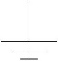 ,
- to set the lid tightening 4 screws M6 with loading from 9,3 to 9,6 Nm,
- to tighten the nut of the cable gland with loading from 20 to 30 Nm,
- to check if the light is functioning by applying the voltage.

2.3 The lights exploitation and the work safety actions should be done according to the requirements of “Electrical engineering regulations”.

2.4 It is necessary to observe the following:
- the installation, assembly and disassembly should be done by the personal having studied the present document and having been instructed on the safety actions while working on the electricity-generating equipment;
- to check visually the light if there are any damages of the housing details and the integrity of the sealing elements.

2.5 It is forbidden:
- to use the light in zones which do not correspond to Ex-marking;
- to unlid the light if it is connected to the power line;
- to use the light without connection to the ground;
- to unscrew pos.4, open the housing with the driver and LED module.

2.6 The connection of the light housing to the ground should be done via a separate cable cord.

2.7 The explosion-proofness of the light is guaranteed by the encasement of the light source, the driver and the contact device inside the explosion-proof housing that prevents the penetration of explosive atmosphere inside the housing.

2.8 The lights are provided with the means that guarantee the explosion-proofness during the exploitation:
- there is the warning label: «DO NOT OPEN WHILE ENERGIZED» (Pic. 9);
- there is inner ground element, there are the ground signs nearby, the light is grounded using a separate cable cord;
- the protective glass is heat-strengthened and heat-resistant;
- the cable is thickened by the cable gland;
- IP up to IEC 529 is not worse than IP65.

2.9 The light installation and the energy supply should be done in strict correspondence to the installation norms and rules for explosive atmospheres acting on the territory of the application country and the present manual.

2.10 Before the installation the light should have the exterior check, a special attention should be paid to the integrity of the housing, the glass.

2.11 The place of the cable cords connection should be thoroughly cleaned to achieve the firm contact.

2.12 In the light exploitation process the maintenance personnel should pay a special attention to the condition of explosion-proofness means, to control the concentration of explosive mixture in production zones.

2.13 Not less than once a year there should be done the light technical maintenance. To do it there should be done the following actions:
- to switch the power off;
- to clean the light and to do the exterior check;
- to take the lid off and to check the contact connections including the ground elements;
- to check the integrity of the gasket ring, to replace the gasket ring (Gasket ring 80-85-25 GOST 9833-73 or analogous) if necessary;
- to assemble the light in the diverse order.

Pic. 4

Pic. 5

Pic. 6

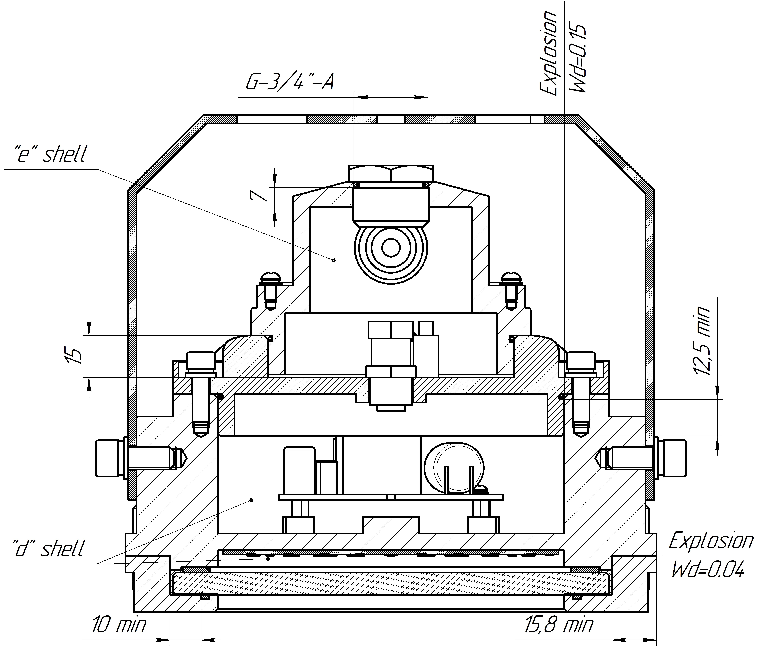

Pic. 7

Pic. 8

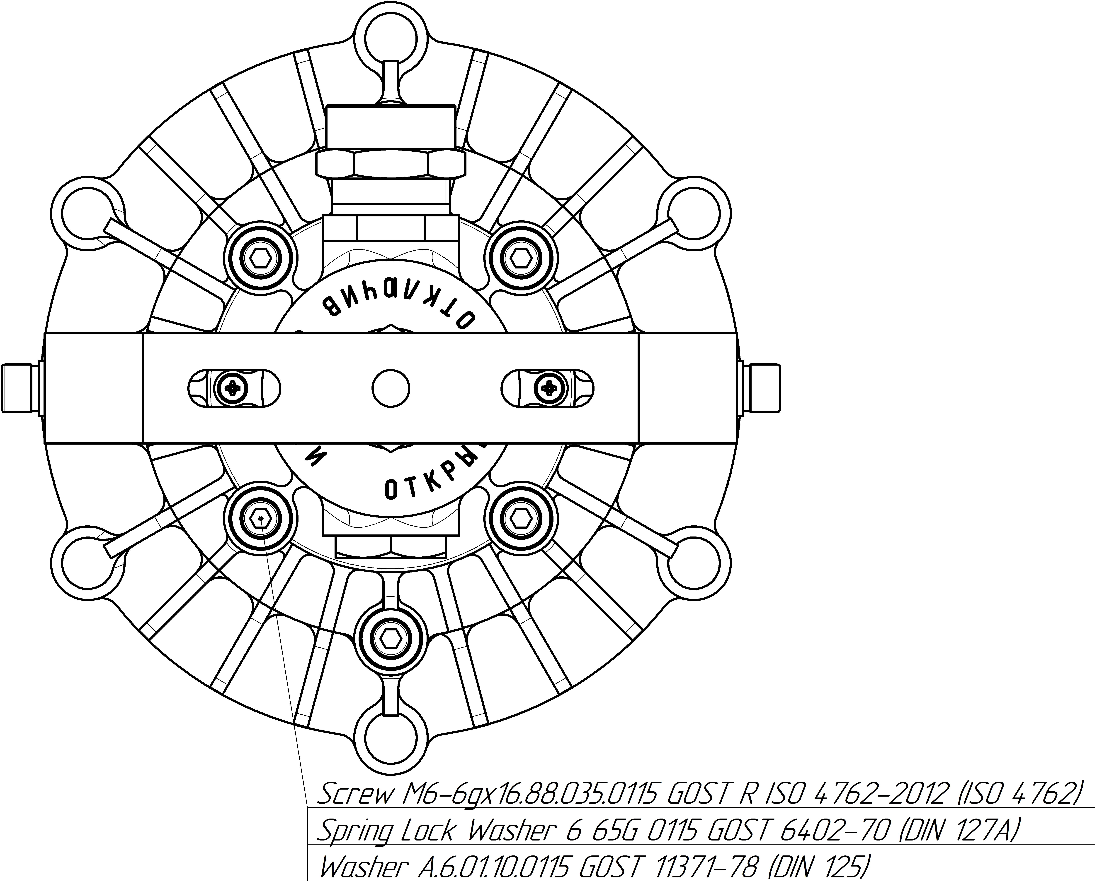

Pic. 9

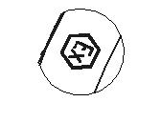
Pic. 10 Pic. 11

Pic. 12 – The scheme of the power connection

Remarks: instead of the blind plug KENS.713535.001 (pic. 6) another certified blind plug can be installed.

3 Storage and transportation
3.1 The light should be kept packed according to GOST 23216 for the storage conditions.

3.2. Transportation of the light can be carried out by any transport at any distance.

3.3. When keeping and transporting the light should be protected against any atmospheric fallout.

4 Recycling
4.1 All materials used in LED Explosion-proof light fixture of “SPV-220-005” type is not dangerous for people’s life and environment. On completing operation, they should be recycled in accordance with the present rules.

5 Manufacturer’s Warranty
5.1 The company-manufacturer guarantees conformance of the light’s requirements to technical specifications and normal operating within 5 years if the customer meets requirements of transportation rules, storage, assemblage and operating rules.

5.2. Within the warranty period damaged lights should be changed charge free by the manufacture at the conditions of observing installation and operating rules by the customer.

5.3 Service life is not less than 10 years.

6 Reclamation Data
6.1. The manufacturer should be laid reclamation claims in case of discovering damages that may lead to the breakdown of LED Explosion-proof light fixture of “SPV-220-005” type before the warranty expiration.
The manufacturer’s address:
19, Leskova str., Orel, 302040, RUSSIA, JSC “Proton”.

6. 2. In reclamation there should be specified:
the light brand, damages, conditions at which they are discovered, the whole operation period.
There should be attached a copy of the payment document for the light.

7 Acceptance Certificate
7.1 LED Explosion-proof light fixture of “SPV-220-005” type is manufactured and approved in accordance with the compulsive State standards requirements, the present technical specifications TS 3461–018–41677105–2016 and approved to be suitable for the operation.

Placeholders QCD stamp

________________________________

Date

