PASSPORT

LED Explosion-proof Light Fixture of
«SVS-220-001» type
KENS.676116.002 PS

1 General Information
1.1 LED Explosion-proof light fixture of «SVS-220-001» type (further named as the light) is used for operating in the AC supply for outdoor and indoor illumination of objects with potentionally explosive atmosphere of fluid, steam, dust or fog.
1.2 The light preserves its working capacity at the following conditions:
- HR up to 95% (at the temperature +40 ̊С);
- ambient operating temperature from minus 50 ̊С up to plus 50 ̊С;
1.3 The light is manufactured and delivered to the customer in version of supplying of AC system with voltage from 100 to 242V and frequency (50±1) Hz with the lighter in terms of LED semiconductive light source.
2. Basic technical data
2.1 AC supply voltage from 100 to 242V.
2.1 AC frequency (50±1) Hz.
2.3 Lighting source – LED semiconductor device.
2.4 The power of light (not more):
SVS-220-001-01 - 45W
SVS-220-001-02 - 30W
SVS-220-001-03 - 20W
SVS-220-001-04 - 60W

2.5 The type of light intensity curve – cosine.
2.6 Light intensity (not less):
SVS-220-001-01 - 3000lm;
SVS-220-001-02 - 2000lm;
SVS-220-001-03 - 1300lm;
SVS-220-001-04 - 6600lm.
2.7 Ex marking 1Ex d op is IIC T5 Gb/ Ex tb IIIC Db.
2.8 The light weight is not more than 8 kg.
2.9 The operating temperature of the light SVS-220-01 is from minus 50°C up to plus 50°C.
2.10 Climatic performance MCC, placement category 1 up to IEC 15150-69.
2.11 Ingress protection IP65 up to IEC 529.
2.12 Working life of the light if conditions of operation are met is not less than 50000 hours.

3. Set (the light complectness):
3.1 The set consists of:
- explosion-proof light fixture of SVS-220-001 type – 1 pce.;
- a passport, an operating manual, a certificate copy and a certificate annex copy;
- a set of bushings and washers - 1 pce.;
- a clip – 1 pce.
3.2 The example of ordering the explosion-proof light of SVS-220-001 type with voltage 220V, development number 001 and hardware version 01:
explosion-proof light fixture of SVS-220-001-01 type TS 3461-011-41677105-2013
4. The device and operating principle
4.1 The light (pic.1) consists of two Ex enclosures (Ex d). The first enclosure consists of a ring (pos.1) with the glass (pos.2) and housing (pos.3) with a LED module (pos.7).
4.2 The second enclosure consists of a housing (pos.4) with driver (pos.10) and contact device (pos.11), a lid (pos.5) with cable gland.
4.3 The glass (pos.3) is a glass translucent element which is hermetically sealed into the metal ring (pos.1). The ring with the glass is hermetically sealed assembly.
4.4 The ring (pos.1) is fixed to the housing (pos.3) by means of hermetically sealed screw joint.
4.5 The driver (pos.4) and contact device (pos.11) are put inside the housing (pos.10)
4.6 The supply of the conductive wires from the driver (pos.10) to the LED module (pos.7) is carried out through special port which is potted with compound.
4.7 The connection of two Ex enclosures is hermetically sealed.
4.8 The supply of network cable to contact device (pos.11) is carried out through hermetic cable entry which is situated on the lid of the light (pos.5).
4.9 The lid (pos.5) is fixed to the housing (pos.4) by means of eight screws M6.
4.10 The hermiticity of lid’s connection (pos.5) with the housing (pos.4) is carried out by means of sealing ring (pos.12).
4.11 The sealing elements and the light’s design provide the exposure protection level not below than IP65.
4.12 The fixture of the light is carried out with the help of the bracket (pos.6)
4.13 The overall view of the light is indicated at pic.1.

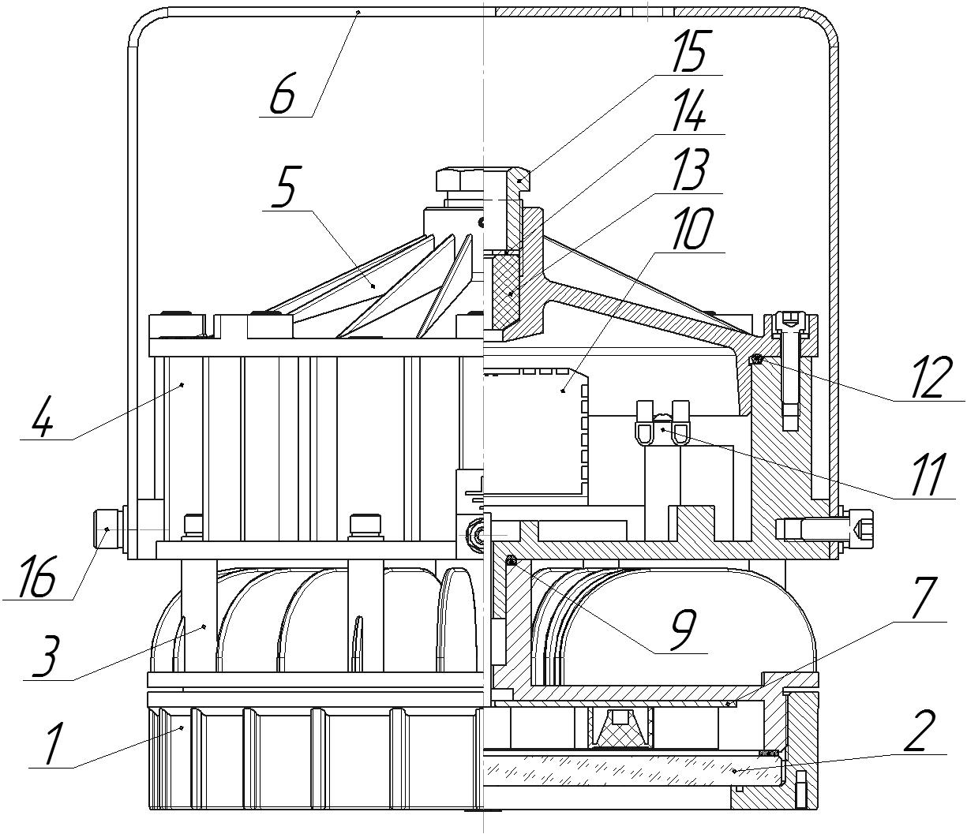

1 – Ring.  2 – Glass.  3 – LED module housing.  4 – Driver’s housing.  5 – Lid.  6 – Bracket.  7 – LED module. | 9 – Sealing ring.  10 – Driver.  11 – Contact device.  12 – Sealing ring.  13 – Sealing bushing.  14 – Washer.  15 – Bushing.  16 – Screw M8

Pic.1

5. Safety precautions
LED lighting source is the source of high –intensity light emission that is dangerous for human eyes. It is forbidden to look at the lighting device at the distance less than 1 meter.
5.1 IP 1 according to IEK 60598-1-2003.
5.2 The IR of the light is not less than 2 megaOhm.

6. Assembly and installation
6.1 The light connection to the supply mains is necessary to organize in the following way (Pic.1):
- turn off the screws and remove the lid (pos.5);
- put the bushing (pos.15), washer (pos.14) and sealing bushing (pos.13) on the cable;
- input the cable through the hole in the lid (pos.5);
- connect the cable conductors to the contacts of contact device (pos.11) and to the ground contact;
- stick the lid (pos.5) by the screws, tighten the screws forcefully (9±0.5) N-m;
- input the sealing bushing (pos.13) and washer (pos.14) to the lid (pos.5), and screw in the bushing (pos.15) until the wires are pressed;
- lock the bushing (pos.15) with the locking screw;
- check the light work by means of voltage supply;
6.2 The organization of light engineering and implementation program of work safety should be carried out according to requirements of “electric engineering repulations”.
6.3 It’s necessary to comply with the following:
- assembly, installation and disassembly should be done by the staff which was studied the following document and instructed about the safety measures while working with the electricity-generating equipment;
- it’s necessary to check the light on the point of absence of components damage and the completeness of sealing elements.
6.4 It is forbidden:
- to use the light in zones which do not correspond to Ex-marking;
- to unlid the light if it is connected to the power line;
- to use the light without connection to the ground;
- to use the light with defects on Ex surfaces.
6.5 The connection of the light housing to the ground should be done via a separate cable cord.
6.6 The light installation and the energy supply should be done in strict correspondence to the installation norms and rules for explosive atmospheres acting on the territory of the application country and the present manual.
6.7 The place of the cable cords connection should be thoroughly cleaned to achieve the firm contact.
6.8 The holding of the bracket to the light should be done by means of two screws (pos.16) which are turned forcefully (22±1) N-m.

7. Technical maintenance
7.1 In the light exploitation process the maintenance personnel should pay a special attention to the condition of explosion-proofness means which provide the prevention and blast isolation inside the light, should also control the concentration of explosive mixture in production zones.
7.2 Not less than once a year there should be done the light technical maintenance. To do it there should be done the following actions:
- to switch the power off;
- to clean the light and to do the exterior check;
- to take the lid off and to check the contact connections including the ground elements;
- to check the integrity of the sealing cord, to replace the sealing cords if necessary;
- to assemble the light in the diverse order.

8. Possible damages and its remedies
8.1 In case of LEDs breakdown the light is beyond repair.

9. Marking and preservation
The marking is put on the light outer surface on the clearly visible place via the way that guarantees the stability to the environment influence and contains:
9.1 Marking of light type:
- the trademark of the manufacturer;
- the name of the company;
- the light type;
- the technical conditions logical number;
- the address of the company-manufacturer.
9.2 Ex marking:
- controlled supply voltage;
- maximum power consumption;
- ambient temperature range;
- IP code;
- manufacturing year and month;
- the light serial number;
- the certification body name or sign and the certificate No.;
- special Ex-marking for explosive gas or dust atmosphere.

10. Storage and transportation

10.1 The light should be kept packed according to GOST 23216 for the storage conditions.
10.2. Transportation of the light can be carried out by any transport at any distance.
10.3. When keeping and transporting the light should be protected against any atmospheric fallout.

11. The life and keeping time
11.1 The light lifetime is not less than 50000 hours.
11.2 The keeping time is 3 years from the day of production.

12. Acceptance Certificate
The explosion-proof light fixture of «SVS-220-001» type with the serial No _________ is manufactured in accordance with specifications TS 3461–011–41677105–2013 and proved to be suitable for operating.
Stamp_______ (Signature) __________(Signature clarification)
QCD
Issue Date_____________________

13. Recycling Data
13.1 All the materials of which the explosion-proof light fixture of «SVS-220-001» type is manufactured are not dangerous for the life and health of people and the environment.
13.2 On completing the operation of the light, it does not require a special recycling and should be handed as a recyclable material in accordance with the present rules.

14. Warranty
14.1 The manufacturer guarantees the conformance of the light to the technical specifications and normal work within 5 years since operating it at condition of observing the rules of transportation, storage and installation.
14.2 Within the warranty period damaged lights should be changed charge free by the manufacture at the conditions of the conformance to the installation and operating rules by the customer.

15. Reclamation Data
15.1 The manufacturer should be laid reclamation claims in case of discovering damages that may lead to the breakdown of LED Explosion-proof light fixture of “SVS-220-001” type before the warranty expiration.
The manufacturer’s address:
19, Leskova str., Orel, 302040, RUSSIA, JSC “Proton”.
15.2 In reclamation there should be specified:
the light brand, damages, conditions at which they are discovered, the whole operation period.
There should be attached a copy of the payment document for the light.

