JSC “Proton”

LED Explosion-proof Light Fixture of
«SVS-220-001» type

OPERATING MANUAL
KENS. 676116.002 OM

JSC «Proton»
Orel
The present operating manual (further named OM) is used for operating LED Explosion-proof light fixture of “SVS-220-001” type (further named the light).
The OM contains construction data, operating rules and working conditions, maintenance recommendations and other data necessary for the right operating of the light.
Only after being instructed, going through safety working methods, checking of safety rules with further certifying a qualification for safety arrangements, one is admitted for electrical installation, inspection and maintenance of the light unit.

1 Description and Operating
1.1 Light Assignment
1.1.1 The light is used for operating in the AC supply for outdoor and indoor illumination of industrial objects with potentionally explosive almosphere of fluid, steam, dust or fog.
1.1.2 The light is designed to work from external power supply.
1.1.3 The index of graphical symbols of the light:
S – light
V – explosion-proof
S – LED

1.2 Technical data
1.2.1 AC power supply from 100 to 242V.
1.2.2 AC frequency 50Hz.
1.2.3 Light source – LED semiconductor device.
1.2.4 The light power consumption, nominal **:
SVS-220-001-01 - 45 W;
SVS-220-001-02 - 30 W;
SVS-220-001-03 - 20 W;
SVS-220-001-04 - 60 W.
** Consumption power value can differ by 10%.
1.2.5 Light distribution curve – cosine.
1.2.6 Light intensity, not less than:
SVS-220-001-01 - 3000 Lm;
SVS-220-001-02 – 2000 Lm;
SVS-220-001-03 - 1300 Lm;
SVS-220-001-04 - 6600 Lm.
1.2.7 Ex marking: 1 Ex d op is IIC T5 Gb/ Ex tb IIIC Db.
1.2.8 The light weight is not more than 8 kg.
1.2.9 Ambient operating temperature of the light SVS-220-001 is from minus (50±3)°С up to plus (50±3)°С.
1.2.10 Climatic performance MCC, placement category 1 up to IEC 60721-2-1:2013:1982, IEC 60068-1:2013.
1.2.11 IP up to IEC 529 is not worse than IP65.
1.2.12 Durability when conforming to operating conditions is not less than
50 000 hours.
1.2.13 The light physical configuration corresponds to the physical configuration samples description KENS.676116.002 D2.
1.2.14. The outward design and construction of the light are shown on Pic.1.

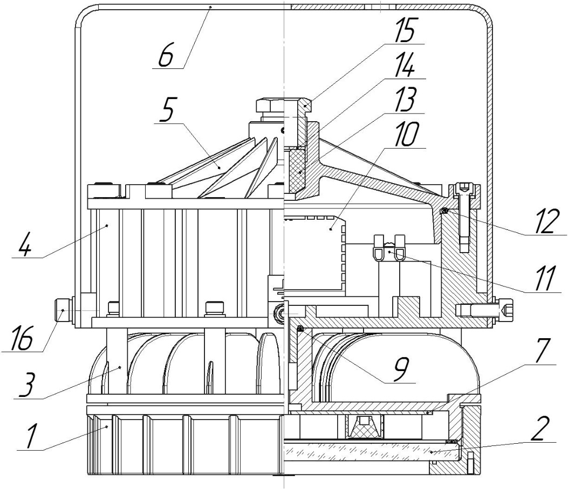

1 – Ring.  2 – Glass.  3 – LED module housing.  4 – Driver’s housing.  5 – Lid.  6 – Bracket.  7 – LED module. | 9 – Sealing ring.  10 – Driver.  11 – Contact device.  12 – Sealing ring.  13 – Sealing bushing.  14 – Washer.  15 – Bushing.  16 – Screw M8

1.3 Set (the light complectness):
1.3.1 The set consists of:
- explosion-proof light fixture of SVS-220-001 type – 1 pce.;
- a passport, an operating manual, a certificate copy and a certificate annex copy;
- a set of bushings and washers - 1 pce.;
- a clip – 1 pce.

1.4 Construction and Operation
1.4.1 LED Explosion-proof light fixture of “SVS-220-001” type (see Pic. 1) consists of the ring (pos.1) with the glass (pos.2), housing (pos.3) with installed LED module (pos.7), housing (pos.4) with the driver (pos.10), contact device (pos.11), lid (pos.5) with sealing bushing (pos.13), washer (pos.14) and bushing (pos.15), also sealing rings (pos.9) (pos.12) and fixture elements.
1.4.2 The designation of constitutive parts of the light (see Pic.1):
- the bracket (pos.6) is used for light holding;
- the holding of the bracket is fixed to the light with 2 screws (pos.16) which are screwed up forcefully with 23 N-m;
- the connection of the network cable is done to the contact device (pos.11);
- the way of connection of ring (pos.1), glass (pos.2), housing (pos.3), housing (pos.4) and lid (pos.5) guarantees the necessary hermeticity and the light protection;
- the sealing elements provides the light protection level from external factors influence not worse than IP65.

1.5 Measuring tools, instruments, accessories
1.5.1 To open the explosion-proof housing, to connect the light to the network, to install and maintain preventively the usual electro-installation instruments and measuring tools are used.

1.6 Marking
The marking is put on the light outer surface on the clearly visible place via the way that guarantees the stability to the environment influence and contains:
1.6.1 Marking of light type:
- the trademark of the manufacturer;
- the name of the company;
- the light type;
- the technical conditions logical number;
- the address of the company-manufacturer.
1.6.2 Ex marking:
- controlled supply voltage;
- maximum power consumption;
- ambient temperature range;
- IP code;
- manufacturing year and month;
- the light serial number;
- the certification body name or sign and the certificate No.;
- special Ex-marking for explosive gas or dust atmosphere.

1.7 Packaging
1.7.1 The package of the light is made according to GOST 23216 for storage conditions 2 (c) IEC 60721-2-1:2013:1982, IEC 60068-1:2013.
1.7.2 The lights should be packed into a cargo container that provides their safety.
1.7.3 Manipulation signs should be marked on the cargo container: “Fragile”, “Keep dry”, “Top”, “Max quantity when stocking” according to ISO 780:2015.

2 Intended Usage

2.1 The light connection to the supply mains is necessary to organize in the following way (Pic.1):
- turn off the screws and remove the lid (pos.5);
- put the bushing (pos.15), washer (pos.14) and sealing bushing (pos.13) on the cable;
- input the cable through the hole in the lid (pos.5);
- connect the cable conductors to the contacts of contact device (pos.11) and to the ground contact;
- stick the lid (pos.5) by the screws;
- tighten the screws forcefully 9.4 N-m;
- input the sealing bushing (pos.13) and washer (pos.14) to the lid (pos.5), and screw in the bushing (pos.15) until the wires are pressed;
- lock the bushing (pos.15) with the locking screw;
- check the light work by means of voltage supply;

2.2 The lights exploitation and the work safety actions should be done according to the requirements of “Electrical engineering regulations”.

2.3 It is necessary to observe the following:
- the installation, assembly and disassembly should be done by the personal having studied the present document and having been instructed on the safety actions while working on the electricity-generating equipment;
- to check visually the light if there are any damages of the housing details and the integrity of the sealing elements.

2.4 It is forbidden:
- to use the light in zones which do not correspond to Ex-marking;
- to unlid the light if it is connected to the power line;
- to use the light without connection to the ground;
- to use the light with defects on Ex-surfaces, paint out the surfaces “Explosion”.

2.5 The connection of the light housing to the ground should be done via a separate cable cord.

2.6 The explosion-proofness of the light is guaranteed by the encasement of the light source, the driver and the contact device inside the explosion-proof housing that prevents the penetration of explosive atmosphere inside the housing.

2.7 The lights are provided with the means that guarantee the explosion-proofness during the exploitation:
- there is the warning label: «DO NOT OPEN WHILE ENERGIZED» (Pic.9);
- there are inner and outer ground elements, there are the ground signs nearby, the light is grounded using a separate cable cord;
- the protective glass is heat-resistant;
- the cable is thickened by the cable entry (pic.6);
- IP up to IEC 529 is not worse than IP65.

2.8 The light installation and the energy supply should be done in strict correspondence to the chapter 3.4 OCEI (operational code for electric installations) and SI (safety instructions), “Instruction on electric equipment installation of power and lighting networks in explosive zones”, Electrical installation code and the present manual.

2.9 Before the installation the light should have the exterior check, a special attention should be paid to the integrity of the housing, the glass and connections “Explosion”.

2.10 The place of the cable cords connection should be thoroughly cleaned to achieve the firm contact.

2.11 In the light exploitation process the maintenance personnel should pay a special attention to the condition of explosion-proofness means, that provides explosion prevention and localization inside the light, should also control the concentration of explosive mixture in production zones.

2.12 Not less than once a year there should be done the light technical maintenance. To do it there should be done the following actions:
- to switch the power off;
- to clean the light and to do the exterior check;
- to take the lid off and to check the contact connections including the ground elements;
- to inspect the surfaces of “Explosion” (pic.5) (pic.7);
- to check the integrity of the sealing cord, to replace the sealing rings if necessary;
- to assemble the light in the diverse order.

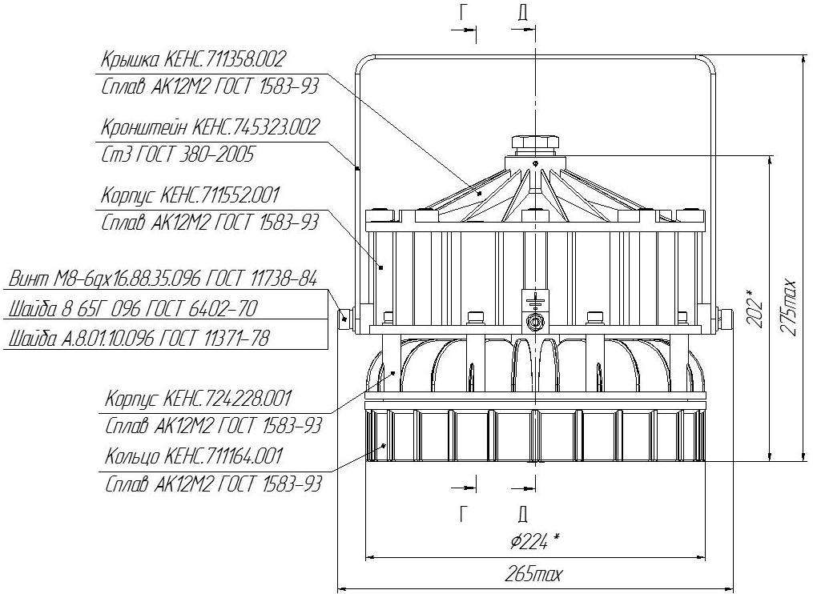
Pic.2

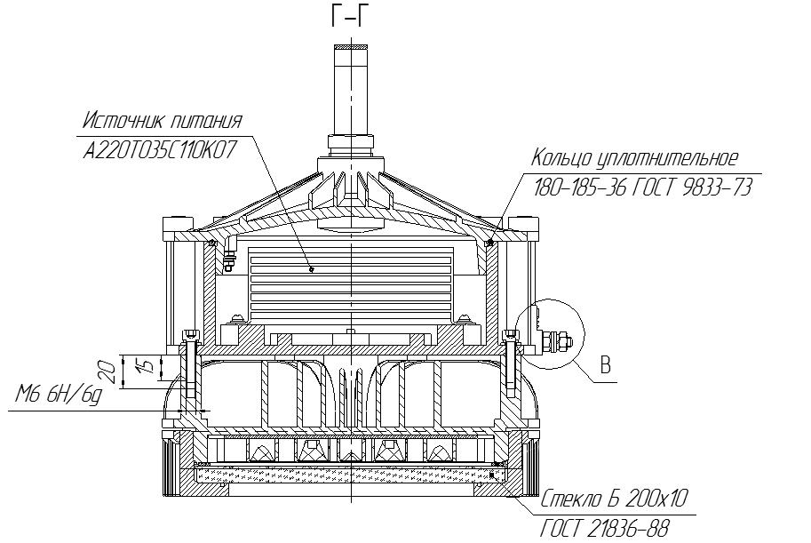
Pic.3
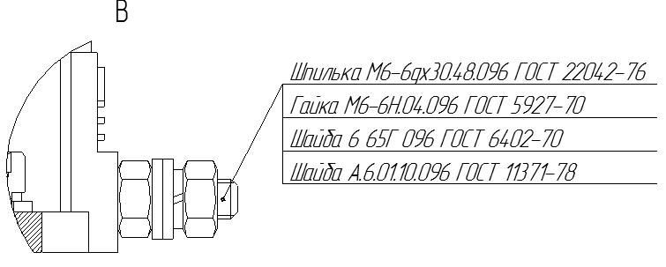
Pic.4
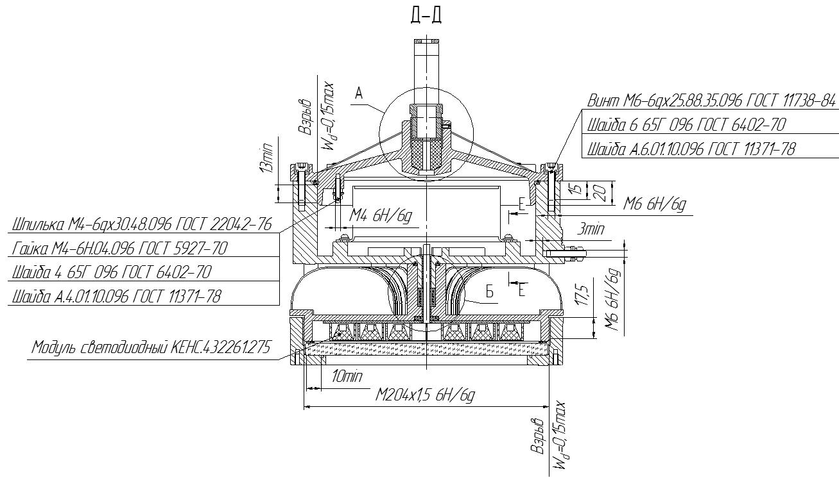
Pic.5
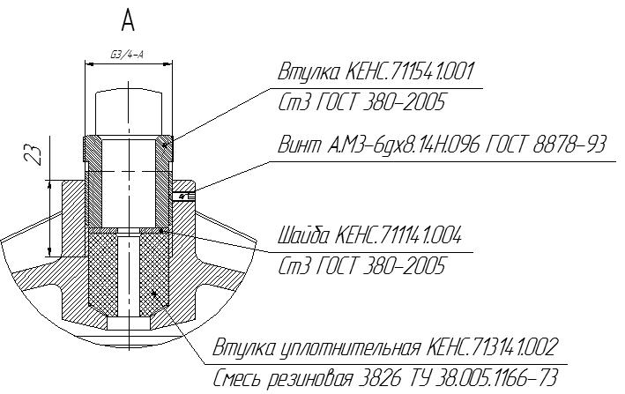
Pic.6
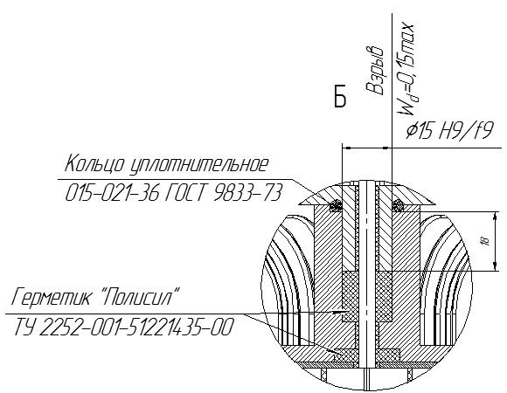
Pic.7
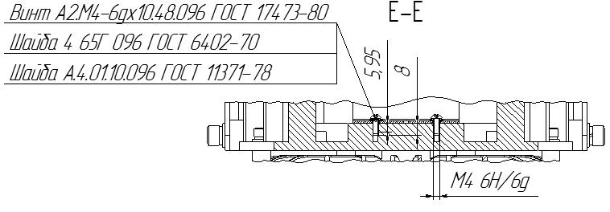
Pic.8

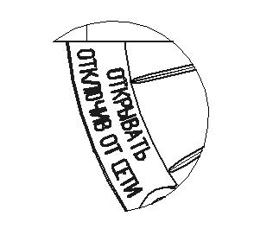

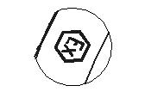

Pic.10

Pic.9

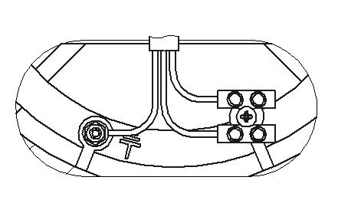

Pic.11 - Connection diagram of the driver

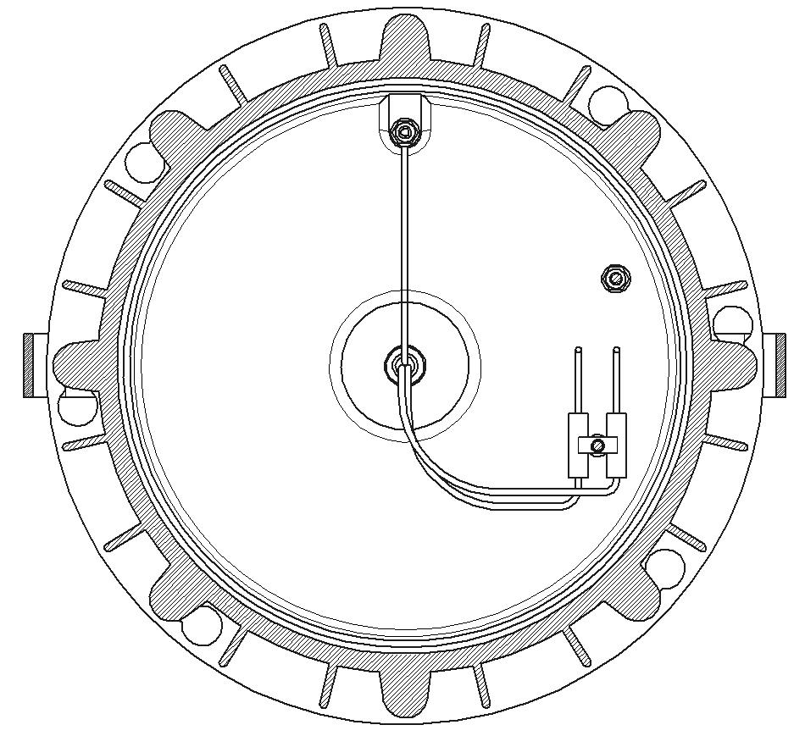
Pic.12 – Connection diagram of the network wire

3 Storage and transportation

3.1 The light should be kept packed according to GOST 23216 for the storage conditions.
3.2. Transportation of the light can be carried out by any transport at any distance.
3.3. When keeping and transporting the light should be protected against any mechanic damage and atmospheric fallout.

4 Recycling

4.1 All materials used in LED Explosion-proof light fixture of “SVS-220-001” type are not dangerous for people’s life and environment. On completing operation they don’t have any special recycling and can be registered as recovered materials in accordance with the present rules.

5 Manufacturer’s Warranty
5.1 The company-manufacturer guarantees conformance of the light’s requirements to technical specifications and normal operating within 5 years if the customer meets requirements of transportation rules, storage, installation and operating rules.
5.2 Within the warranty period damaged lights should be changed charge free by the manufacture at the conditions of observing installation and operating rules by the customer.

6 Reclamation data

6.1. The manufacturer should be laid reclamation claims in case of discovering damages that may lead to the breakdown of LED Explosion-proof light fixture of “SVS-220-001” type before the warranty expiration.
The manufacturer’s address:
19, Leskova str., Orel, 302040, RUSSIA, JSC “Proton”.
6. 2 In reclamation there should be specified:
the light brand, damages, conditions at which they are discovered, the whole operation period.
There should be attached a copy of the payment document for the light.

7 Acceptance Certificate

7.1 LED Explosion-proof light fixture of “SVS-220-001” type is manufactured and approved in accordance with the compulsive State standards requirements, the present technical specifications TS 3461–018–41677105–2016 and approved to be suitable for the operation.

Placeholders QCD stamp

________________________________

Date

