Passport
LED Console Light
of “Trassa-Ex” type
KENS.676253.091 PS
1. General Information
1.1 LED console explosion-proof light of “Trassa-Ex” type (further named as the light) of the white emission is used for operating in the AC or DC supply for inside and outside illuminating of objects with ex-proof zone 2 according to GOST IEC 60079-10-1-2011, in zones which are dangerous of hot dust ignition according to GOST IEC 61241-1-2-2011. The light has a housing of the aluminum anodize profile with a protective glass from shatterproof optical protected against UV PC.
The Ex-marking of the light according to table 1.
Table 1.
The light marking | The light type | The Ex-marking for explosive gas atmosphere | The Ex-marking for explosive dust atmosphere
Trassa-1-Ex | SKS-A,B,C,D-220-001-N,T-MCC1-Ex | Ex nR II T4 Gc | DIP A21 T_{A} (110…135)°C
 | SKS-A,B,C,D-220-001-01-N,T-MCC1-Ex
Trassa-2-Ex | SKS-A,B,C,D-220-002-N,T-MCC1-Ex | Ex nR II T4 Gc | DIP A21 T_{A} (110…135)°C
 | SKS-A,B,C,D-220-002-01-N,T-MCC1-Ex
Trassa-3-Ex | SKS-A,B,C,D-220-003-N,T-MCC1-Ex | Ex nR II T4 Gc | DIP A21 T_{A} (110…135)°C
 | SKS-A,B,C,D-220-003-01-N,T-MCC1-Ex
Trassa-4-Ex | SKS-A,B,C,D-220-004-N,T-MCC1-Ex | Ex nR II T4 Gc | DIP A21 T_{A} (110…135)°C
 | SKS-A,B,C,D-220-004-01-N,T-MCC1-Ex
Trassa-5-Ex | SKS-A,B,C,D-220-005-N,T-MCC1-Ex | Ex nR II T4 Gc | DIP A21 T_{A} (110…135)°C
 | SKS-A,B,C,D-220-005-01-N,T-MCC1-Ex
Trassa-6-Ex | SKS-A,B,C,D-220-006-N,T-MCC1-Ex | Ex nR II T4 Gc | DIP A21 T_{A} (110…135)°C
 | SKS-A,B,C,D-220-006-01-N,T-MCC1-Ex
The light can be installed on the console.
1.2 The light preserves its working capacity at the following conditions:
- HR up to 95% (at the temperature +40°С);
- ambient operating temperature from minus 40°С up to plus 60°С.
1.3 Technical data of the light:
- operating supply voltage 220 VAC and frequency 50Hz. The range of supply voltage is from 140V to 265V, the current is alternate (50±10%) Hz or from 200 to 370 VDC;
- electrical and illuminating parameters of the light should correspond to the meanings that are pointed in table 2.
Table 2.
The light marking | The light type | Luminous flux*, not less than, lm | Rated input**, W
Trassa-1-Ex | SKS-A,B,C,D-220-001-N,T-MCC1-Ex | 3 600 | 30
 | SKS-A,B,C,D-220-001-01-N,T-MCC1-Ex
Trassa-2-Ex | SKS-A,B,C,D-220-002-N,T-MCC1-Ex | 7 200 | 60
 | SKS-A,B,C,D-220-002-01-N,T-MCC1-Ex
Trassa-3-Ex | SKS-A,B,C,D-220-003-N,T-MCC1-Ex | 10 800 | 90
 | SKS-A,B,C,D-220-003-01-N,T-MCC1-Ex
Trassa-4-Ex | SKS-A,B,C,D-220-004-N,T-MCC1-Ex | 14 400 | 120
 | SKS-A,B,C,D-220-004-01-N,T-MCC1-Ex
Trassa-5-Ex | SKS-A,B,C,D-220-005-N,T-MCC1-Ex | 18 000 | 150
 | SKS-A,B,C,D-220-005-01-N,T-MCC1-Ex
Trassa-6-Ex | SKS-A,B,C,D-220-006-N,T-MCC1-Ex | 21 600 | 180
 | SKS-A,B,C,D-220-006-01-N,T-MCC1-Ex
* Luminous flux is pointed for LED module at the chip’s temperature 25°C. To know the exact light luminous flux please see ies-file.
** consumption power value can differ by 10%;
- color temperature: T - (warm luminous color) from 3 000 K to 4 000 K, N (normal luminous color) from 4 000 K to 6 000 K;
- ripple factor of the light flux is not more than 5%;
- IP of the housing is not less than IP67 according to GOST 14254-96;
- climatic category MCC, environmental class 1 according to GOST 15150-69;
- electric shock protection class 1 up to STATE STANDARD R MEK 60598-1;
- insulation resistance of live parts is not less than 20 МОm;
- grounding resistance is not more than 0,5 Оm;
- power factor is not less than 0,9;
- the weight of the light should correspond to the meanings that are pointed in table 3.
Table 3.
The light marking | The light type | The weight of the light, kg, not more than
Trassa-1-Ex | SKS-A,B,C,D-220-001-N,T-MCC1-Ex | 2.7
 | SKS-A,B,C,D-220-001-01-N,T-MCC1-Ex | 3.1
Trassa-2-Ex | SKS-A,B,C,D-220-002-N,T-MCC1-Ex | 4.5
 | SKS-A,B,C,D-220-002-01-N,T-MCC1-Ex | 4.9
Trassa-3-Ex | SKS-A,B,C,D-220-003-N,T-MCC1-Ex | 6
 | SKS-A,B,C,D-220-003-01-N,T-MCC1-Ex | 6.4
Trassa-4-Ex | SKS-A,B,C,D-220-004-N,T-MCC1-Ex | 7.7
 | SKS-A,B,C,D-220-004-01-N,T-MCC1-Ex | 8.5
Trassa-5-Ex | SKS-A,B,C,D-220-005-N,T-MCC1-Ex | 8.9
 | SKS-A,B,C,D-220-005-01-N,T-MCC1-Ex | 9.7
Trassa-6-Ex | SKS-A,B,C,D-220-006-N,T-MCC1-Ex | 10.4
 | SKS-A,B,C,D-220-006-01-N,T-MCC1-Ex | 11.2

1.2.19 General form, construction and overall sizes of the light are pointed on pic.1:
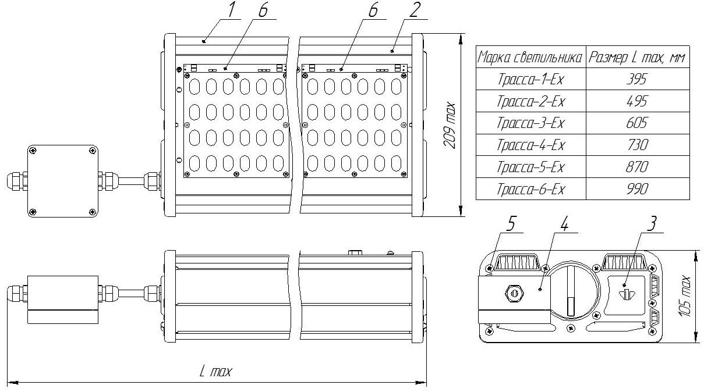
1 – housing; 2 – protective glass; 3 – lid; 4 – terminal block; 5 – screw machine; 6 – LED module.
Pic.1

- fire safety is up to NPB 249-97, IEC 60598-1;
- the lifetime of the light is not less than 100 000 hours if application conditions are met.
- storage from the date of its being manufactured is 3 years.
2. Completeness (set) of the light:
2.1 The set consists of:
- a light – 1 pce.,
- a fixing set – 1 pce (only for SKS-A,B,C,D-220-(001-006)-01-N-T-MCC1-Ex)
- a passport – 1 pce.,
- an operating manual – 1 pce.,
- a certificate copy and a certificate annex copy – 1 pce.,
- a package – 1 pce.
3. Acceptance Certificate
3. 1 The light is manufactured in accordance with specifications TS 3461–013–41677105–2015 and proved to be suitable for operating.
Stamp_______ (Signature) ___________(Signature clarification)
QCD
Plant No.___________ Issue Date_____________________

4. Recycling Data
4.1 All the materials of which the light is manufactured are not dangerous for the life and health of people and the environment and are in conformance with IEC 60598-1.
4.2 On completing the operation of the light, it does not require a special recycling and should be handed as a recyclable material in accordance with the present rules.

5. Warranty
5.1 The manufacturer guarantees the conformance of the light to the technical specifications and normal work within 5 years since operating it at condition of observing the rules of transportation, storage and installation.
5.2 Within the warranty period damaged lights should be changed charge free by the manufacture at the conditions of the conformance to the installation and operating rules by the customer.

6. Reclamation Data
6.1 The order of claiming a reclamation is stated in accordance with the current regulations on the objects of applying.
6.2 The reclamation in a standard form should be claimed to the manufacturer with a compulsive attachment of a discarding act, without which the reclamation cannot be accepted. The copy of bank slip for the device should be enclosed to the act. The reclamation should be forwarded the following address:
19, Leskova str., Orel, 302040, Russia, JSC «Proton»
Tel./ Fax. (4862) 41-44-03

